The Full Code Podcast Supplemental Handout

Podcast Recording: 01 Broadcast Date: April 2026

Podcast Session Title: MDM vs. Time & Audit Readiness

Podcast Speaker/Guest: Courtney Ligocki & Patrice Fedel DNP

MDM, Time, & Audit Readiness: A Clinician’s Quick Guide
Aligned with The Full Code Podcast — “MDM, Time, and Audits: Telling the True Story of Your Visit”

🎧 Q1. The Core Question: MDM or Time?
🎙️ A1. Choosing between Medical Decision Making (MDM) and Time is simply a matter of identifying which one best tells the true story of the visit.
MDM describes your clinical thinking.
Choose MDM when the visit is defined by:
- Multiple or complex problems addressed
- Data you reviewed, ordered, or analyzed
- The level of risk involved in your plan
If your clinical brain did most of the work, MDM is probably the most accurate representation.

🎧 Understanding MDM in Plain Language
MDM has three components:
- Problems Addressed — diagnoses you evaluated or treated during the visit
- Data Reviewed — labs, imaging, notes, external records, conversations
- Risk — medication changes, diagnostic uncertainty, potential complications
You do not need to label anything “moderate complexity.” Just document what work was done and why.
What good MDM documentation includes:
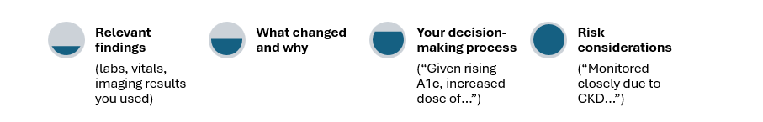

🎧 When to Code Based on Time
Time is a better choice when the minutes (not the medicine) tell the story.

Time can include:  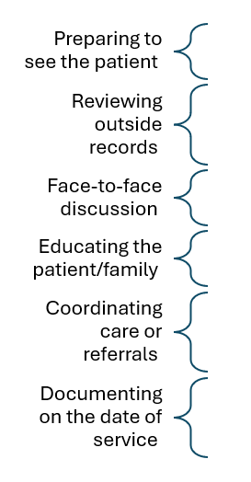 | Requirements for time-based visits:  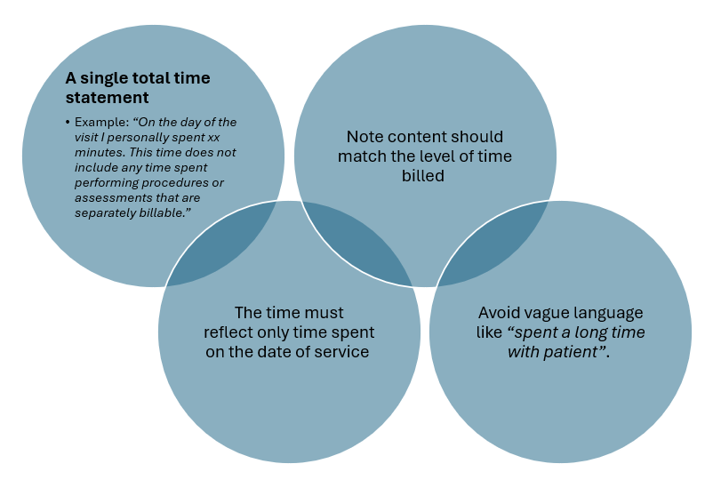

🎧 Real Clinical Scenarios (How to Decide in Practice)
Commonly Seen Clinical Scenarios | Clinician Work Performed | Coding Method Supported
Scenario 1 - Chronic Conditions + Medication Management → MDM | E.g., managing diabetes, HTN, CKD, adjusting meds, interpreting labs | Clinical thinking is doing the heavy lifting → Use MDM
Scenario 2 - Counseling-Heavy Visit → Time | E.g., new cancer diagnosis. Long counseling, reviewing imaging, coordinating referrals. | Time better reflects the work.
Scenario 3 - Simple, Stable Follow-up → MDM | E.g., stable hypertension, medication refill, no changes. | Simple work → Simple MDM.
Scenario 4 - High-Acuity Consult → MDM | E.g., sepsis workup requiring data review and high‑risk decisions. | High-risk MDM is the most accurate.
Scenario 5 - “Double High” Visit → Choose the True One | E.g., highly complex or risky patient presentation in addition to extensive time in counseling or care coordination. | If both time and MDM seem high, select the method that best reflects why the visit was complex — not just the one that yields a higher code.

🎧 What Auditors Actually Look For
Auditors want alignment, not perfection.
They focus on whether your documentation supports:
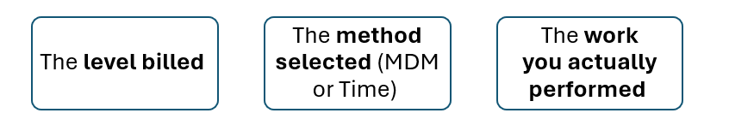

🎧 How Auditors Evaluate MDM
Auditors evaluate exactly three things:
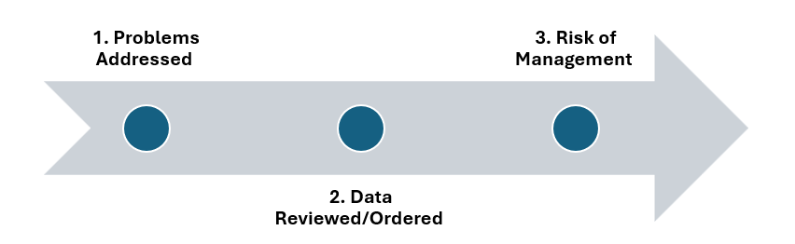
If these elements aren’t documented clearly, visits can look simpler than they truly were.

🎧 How Auditors Evaluate Time
Time audits are straightforward.
They require:
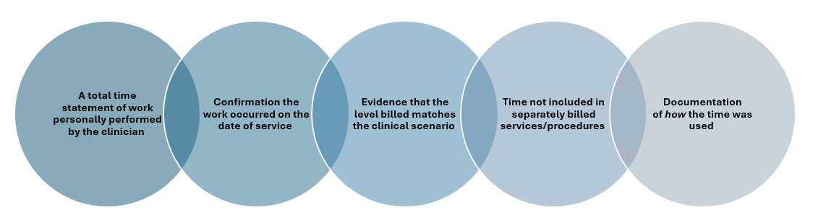
If your note could pass for a 10‑minute visit but lists 45 minutes, that’s a mismatch. Document the activities (education, questions, care coordination) that consumed that time.

🎧 Common Audit Triggers
These are the issues that most often lead to audits:
- High-level codes with thin documentation
- Missing total time statements
- Copy‑forward text not updated for today
- E/M visit billed based on time alongside separately billable services
- Frequent high-level time-based codes where the math doesn’t add up

🎧 Protecting Yourself: Three Habits That Matter Most
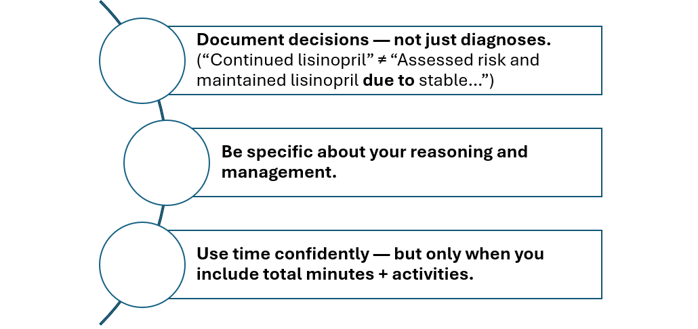Your note should allow someone else to follow your thinking or trace the work you performed.

🎧 The One-Sentence Takeaway
