Register by scanning the QR code
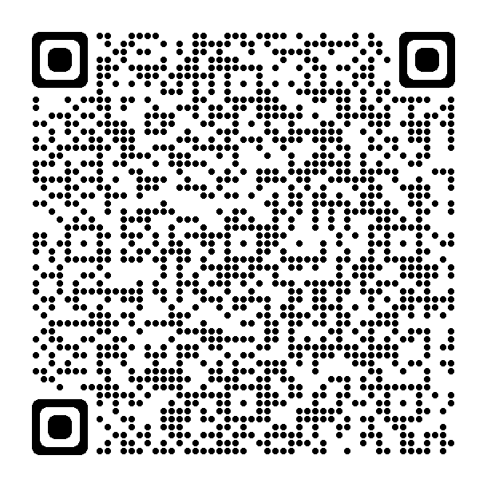
Or Click Here
12th Annual Ventricular Assist Device (VAD) Symposium:
Care of the VAD Patient in the Community
May 12, 2023 / 8:00am-4:15pm / Advocate Christ Medical Center Stein Auditorium

Faculty-directed one day program will cover management of the VAD patient. Topics include basic principles of heart failure, discussion of VAD devices, use of temporary devices, general assessment of VAD patients, blood pressure management, anticoagulation, driveline infections/dressing changes, troubleshooting alarms and post discharge care.

AGENDA:

8:00 am – 8:10 am  8:10 am – 8:30 am | Welcome and Introduction  Lisa Kukla, APN-BC – VAD Coordinator  Basic Principles & Overview of Heart Failure  Katelyn Kuper, FNP-BC – VAD Coordinator
8:30 am – 9:05 am  9:05 am – 9:45 am  9:45 am – 10:00 am  10:00 am – 10:10 am | Bridge to Transplant  KEYNOTE: Jessica Pillarella MD  Advanced Heart Failure, Mechanical Circulatory Support & Transplant Cardiologist  Advocate Christ Medical Center  Heartmate (HM) 2 and 3 Overview  Roxanne Siemeck, MSN, FNP-BC- VAD Coordinator  HM 2 and 3 Demonstration  Diane Kemp, RN – VAD Clinician  BREAK
10:10 am – 10:30 am | HeartWare (HVAD) Overview  Stephen Hicks, FNP-BC – VAD Coordinator
10:30 am – 10:45 am | HVAD Demonstration  Diane Kemp, RN – VAD Clinician
10:45 am – 11:05 am  11:05 am – 11:35 am | Use of Temporary Devices  Nicole Graney, ACNS-BC – VAD Coordinator  General Assessment of VAD Patients  Julie Minser, APN, CVNP-BC, AGPCNP-BC, CHFN – VAD Coordinator
11:35 am – 12:00 pm  12:00 pm – 12:45 pm  12:45 pm – 1:25 pm | Blood Pressure & Anticoagulation  Laura Coyle, MSN, ACNP-BC – VAD Coordinator  LUNCH  Driveline Dressing Change Demonstration  Leah Bardach, MSN, RN, PCCN – VAD Clinician
1:25 pm – 1:55 pm | Troubleshooting Alarms & Device Emergencies  Robin Paliga, MSN, APN – VAD Coordinator
1:55 pm – 2:15 pm  2:15 pm – 2:25 pm | After Implant: Home care, LTAC vs SAR  Leah Bardach, MSN, RN, PCCN – VAD Clinician  BREAK
2:25 pm – 2:45 pm | Patient Perspective Q&A  Kimberly Shells, RN, BSN – VAD Clinician
2:45 pm – 4:00 pm  4:00 pm – 4:15 pm | Breakout Session  Closing Q&A  Lisa Kukla, APN-BC- VAD Coordinator

Objectives:
- Attendees will identify at least one change of practice/lesson learned to safely care for VAD patients.
Target Audience: This activity is designed for registered nurses, advanced practice nurses, EMS, rehabilitation personnel and all other healthcare professionals.
Disclosure: Laura Coyle MSN, ACNP-BC has disclosed she has been a speaker for Medtronic. Roxanne Siemeck MSN, FNP-BC has disclosed being a member of the Independent Practitioner of the Advisory Committee for Medtronic. All other speakers and planners have no financial relationships to disclose. All of the relevant financial relationships listed for these individuals have been mitigated.

Exhibitors: The full listing of Exhibitors will be available on the day of the program. Vendor displays are in an Exhibit Hall, separate area from the auditorium.

Accreditation Statement​:
In support of improving patient care, Advocate Aurora Health is jointly accredited by the Accreditation Council for Continuing Medical Education (ACCME), the Accreditation Council for Pharmacy Education (ACPE), and the American Nurses Credentialing Center (ANCC), to provide continuing education for the healthcare team.​

Credit Statement(s):
American Nurses Credentialing Center (ANCC): Advocate Aurora Health designates this live activity for a maximum of 7.00 ANCC contact hours and 0.3 APRN pharmacological hours. Nurses should claim only the credit commensurate with the extent of their participation in the activity.
This program will also offer education credits for EMS, PT/OT and Speech therapy.
7.0 contact hours approved for EMS personnel
7.0 contact hours approved through IDFPR for IL licensed PT/PTA, OT/COTA
Advocate Healthcare & Hospitals IDFPR CE Sponsor License 216.000106 (PT); 224.000115 (OT)
EMS Contact Person: DeAnn Faragio RN, MSN, CEN, Paramedic deann.faragoi@aah.org
PT/OT Contact Person: Marci Jezierski PT, MPT marcianne.jezierski@aah.org
Speech Therapy Contact Person: Nicole DeLio MA CCC-SLP nicole.delio@aah.org

Created by: Ventricular Assist Device Team Created: 1/10/2023 Revised: 3/10/2023 Post until: 5/12/2023

